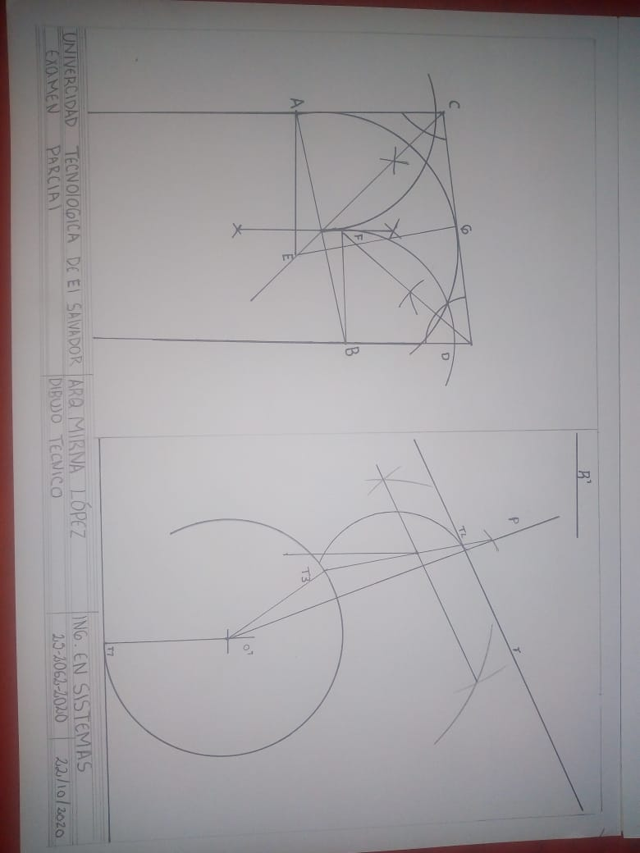

Krissia magali Dueñas Molina 2520622020